Building the Asthma Action Plan Pathway

**Purpose**

This document details the asthma pathways and linked decision tables and cmmns being used for healthcare simulations, including the decisions made in how they have been built. The pathways in this document have built with the asthma action plan for school aged children as the focus. We aim to expose the points at which an asthma action plan would be created, edited and viewed and what data can be seen and is exchanged at these points as well as model differences that an asthma action plan could have on hospital admission rates.

**Generalised Pathways.**

The ‘**Children up to Year 13 School and Mortality’** pathways have been used for this model to narrow the cohort to only school age children and simulate any deaths that may happen. Details on these pathways can be found in the folder containing the pathways (Dropbox/Documents/SimulationsForHealth/OMGClinicalPathways/General/ Children up to Year 13 School and Mortality).

**The Biological Asthma pathway.**

The agent in the Biological Asthma pathway is the patients’ condition which can change from not asthmatic to asthmatic. This is not a diagnosis of asthma, rather a condition which may or may not have presented itself as symptoms yet. The patient is born and is assigned as an asthmatic to be or not. The then wait the assigned time until their asthma sets in. At this point the patient moves to the asthma triggers case where, dependent upon how severe their symptoms are, they will have symptoms and attacks.

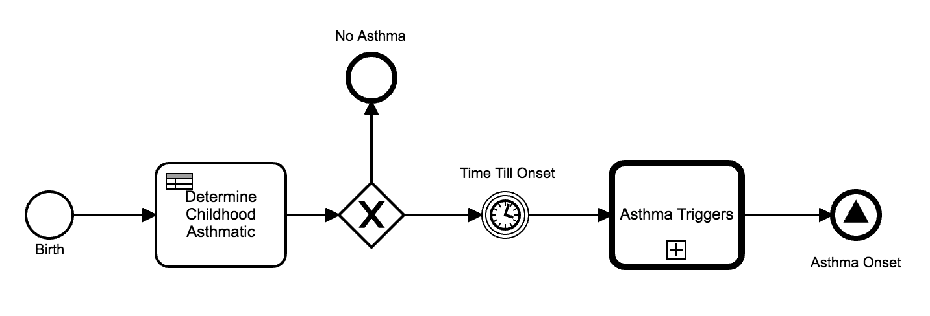

**Determining Childhood Asthma.**

The patients’ chances of developing asthma or not (based on available statistics [1]) are set using the decision table below. If they will become asthmatic they are given a severity (again based on available statistics https://www.asthma.org.uk/about/media/facts-and-statistics/ [2]) and a time (randomly assigned) until the asthma will set in and they will start experiencing symptoms.

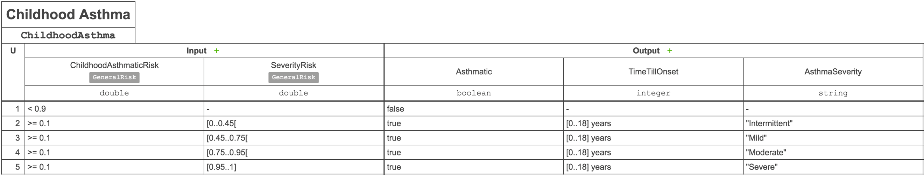

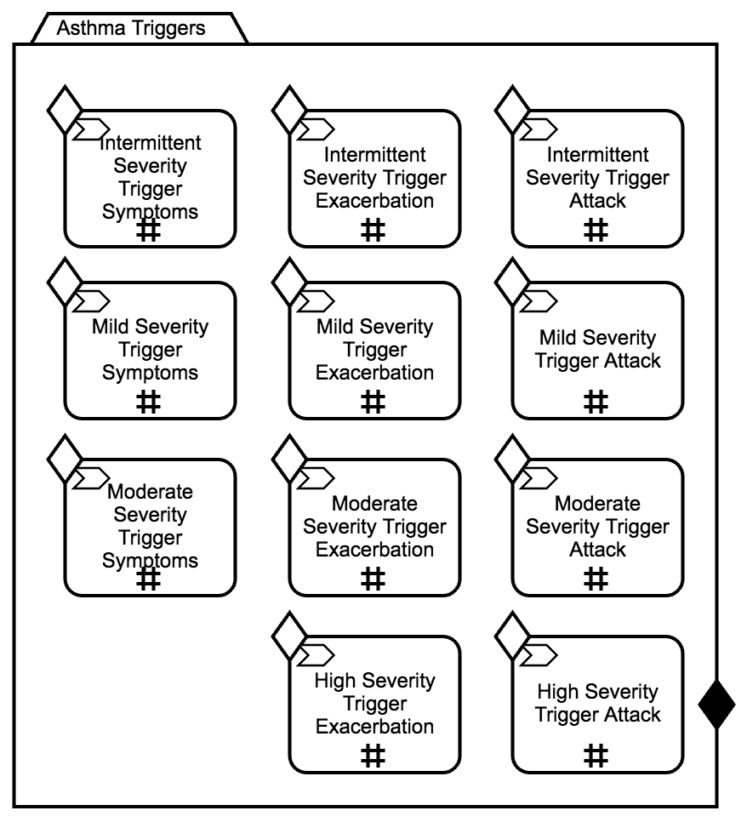**Triggering Asthma Symptoms.**

Within the asthma triggers case the patient will enter the nodes that apply to their severity. The nodes will then repeatedly trigger symptoms (mild), exacerbations (moderate) and attacks (high) in line with their asthma severity[3]. When a trigger happens, the patient has a chance of experiencing less severe symptoms or no symptoms at all if their compliance is high enough. Therefore, the time between these triggers repeating is set to the more frequent end of the descriptions of symptoms frequency for each classification.

**Asthma Symptoms pathway.**

Whenever an asthmatic patient has symptoms triggered from the Asthma Triggers case they are put onto this pathway. If their symptoms do not trigger then they proceed straight to the “No Asthma Symptoms” node until they have another trigger. Otherwise the patient is now experiencing the symptoms with severity dictated by the trigger from the Asthma Triggers case. The patient then suffers from the asthma symptoms for the times shown below according to the severity, allowing time for any medication taken to have effect before the chance of the symptoms continuing are calculated. The Risk of Continuing Symptoms can result in Recovery or the symptoms can continue with a severity dictated in the table. If the symptoms continue then a calculation of the patients’ risk of death is made and the patient proceeds to the Asthma Related Death node or loops back to waiting to reassess accordingly.

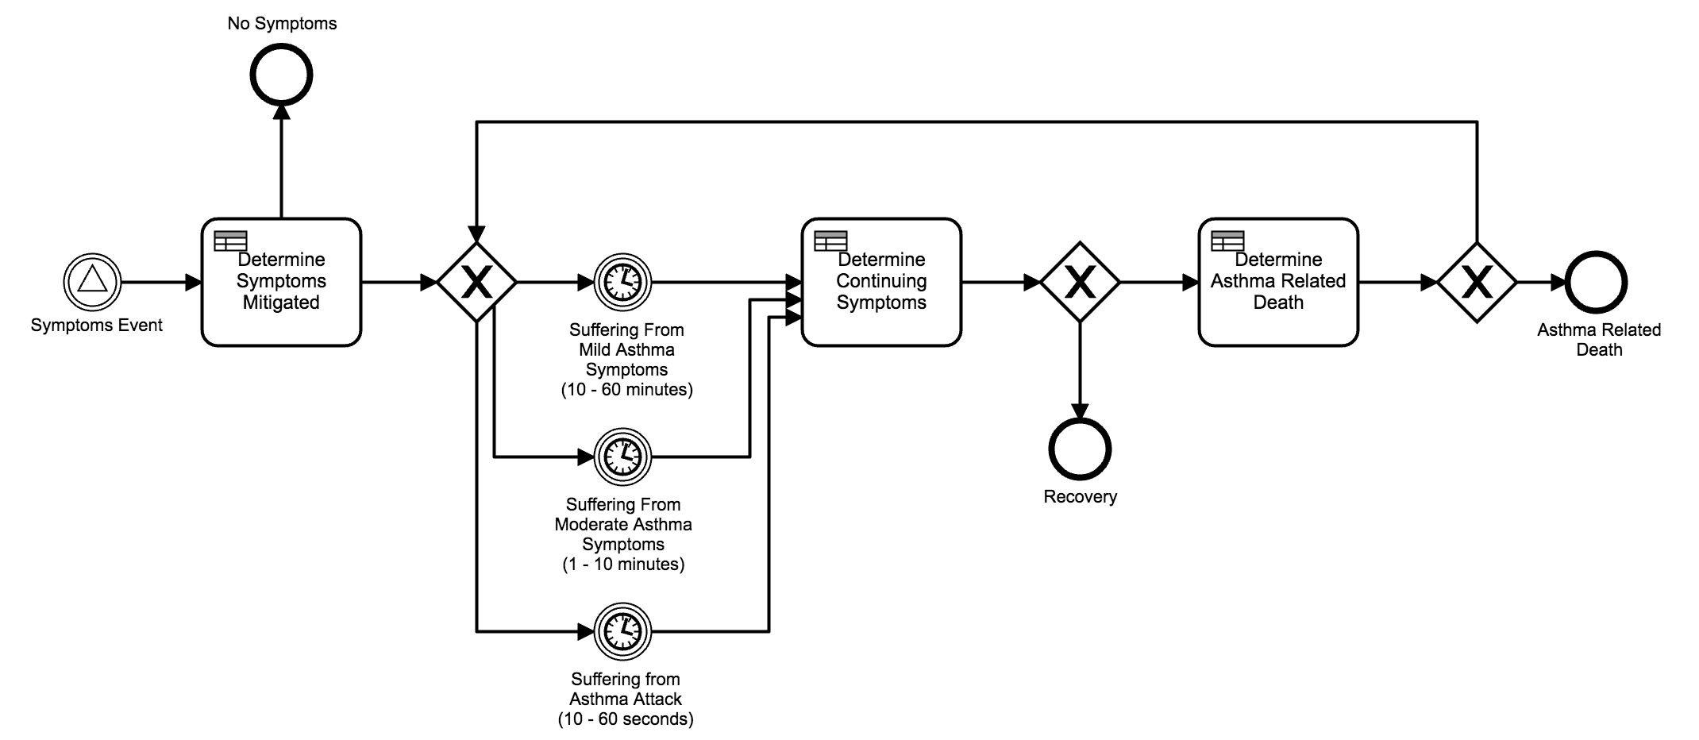

**Mitigating/Exacerbating Symptoms.**

When a patient gets symptoms. the severity may get worse or better depending on the patient’s compliance.

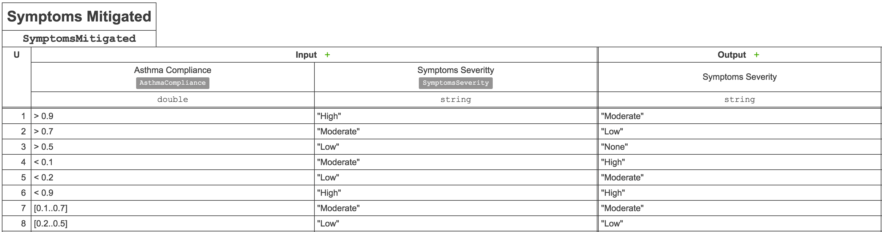

**Risk of Continuing Symptoms.**

The ContinuingSymptomsRisk is calculated with the following risk calculation. Weightings and calculation will be adjusted to get the simulation to match available statistics.

|  |  |  |  |  |
| --- | --- | --- | --- | --- |
| Name | DataType | Constraint | Calculation | Weighting |
| Asthma Severity | String | ["High",  "Moderate",  "Mild",  "Intermittent"] | [x = "High" = 1,  x = "Moderate" = 0.7,  x = "Mild" = 0.4,  x = "Intermittent" = 0.1] | 0.1 |
| Symptoms Severity | String | ["Severe",  "Moderate",  "Mild"] | [x = "Severe" = 0.9,  x = "Moderate" = 0.7,  x = "Mild" = 0.4] | 0.5 |
| Medication Taken | Integer | > 0 | [x < 1 = 0.6,  x > 1 && x < 6 = 0.4,  x > 5 && x < 10 = 0.2,  x > 10 = 0] | 0.3 |
| AsthmaRelatedDeathRisk | String |  | [x = true = 1,  x = false = 0] | 0.05 |
| General Risk | Double | [>= 0, <= 1] |  | 0.05 |

**Determining Continuing Symptoms.**

Depending on the result of the ContinuingSymptomsRisk calculation, the symptoms can continue at each severity, change severity or stop entirely.

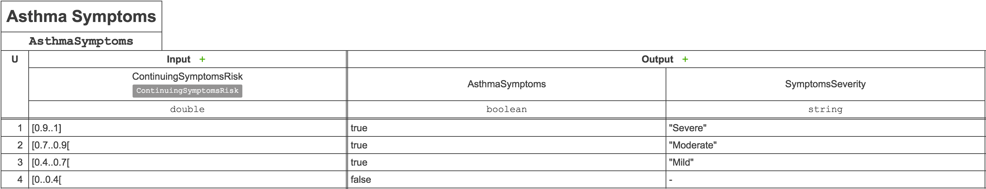

**Determining Asthma Related Deaths.**

If the patient has not recovered then the AsthmaRelatedDeathRisk used to determine if the patient may die. The patient must have a predisposition to death from asthma and be having a high severity attack to have a small chance of dying from asthma symptoms. The numbers used to generate this result will be adjusted to get the simulation to match available statistics.

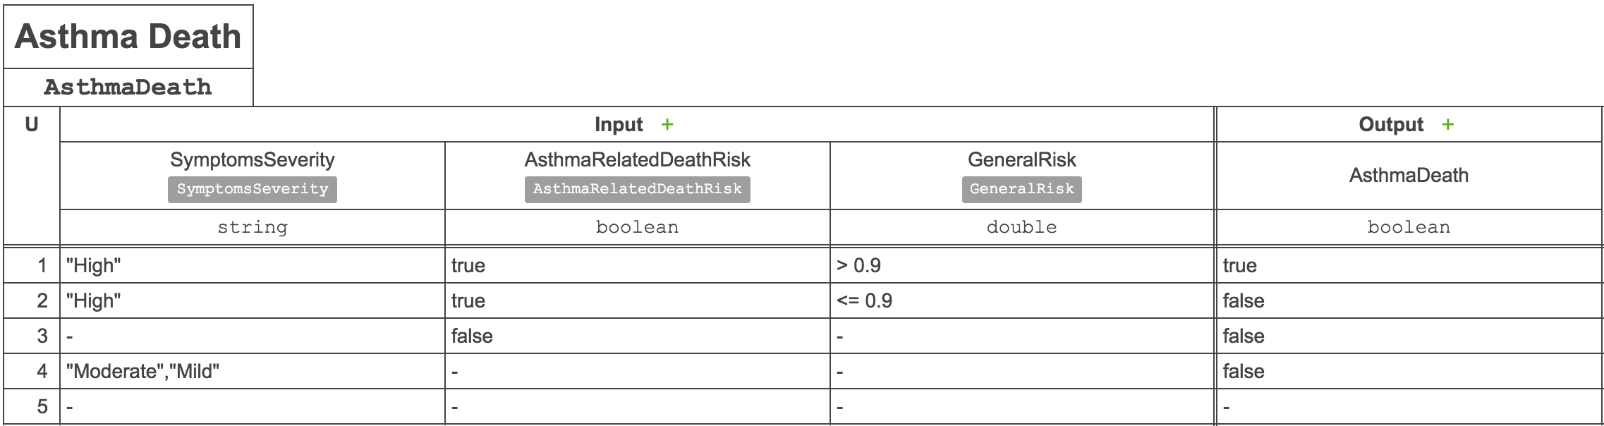

**Asthma Symptoms Response Pathway:**

When the patient experiences symptoms this pathway models the choices they, or their adult supervision, make as their symptoms progress.

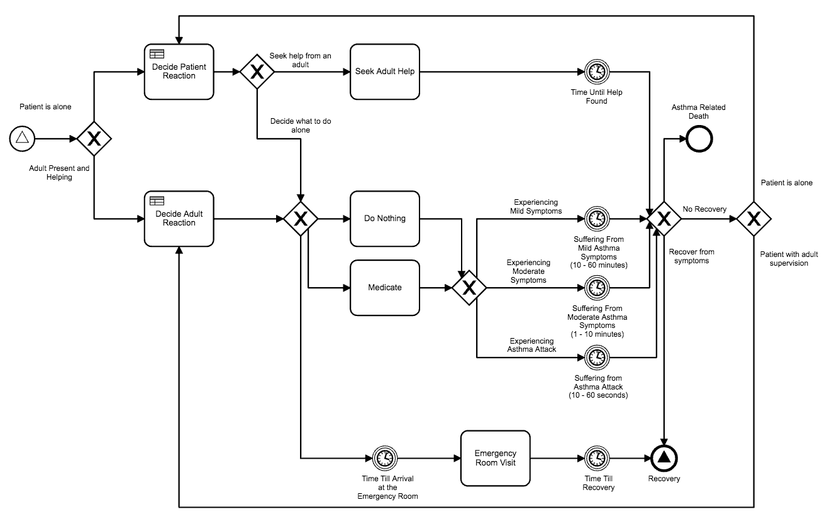

**Decided Upon Reactions.**

The patient will decide what they should do based on severity, diagnosis, asthma management etc. If the patient is alone, they have the option to seek adult help. Alone or not, they may decide to do nothing or self-treat with their inhaler and will wait for a reasonable amount of time for their symptoms until they reassess their situation. They could also decide that their symptoms are severe enough and/or persistent enough to seek emergency treatment.

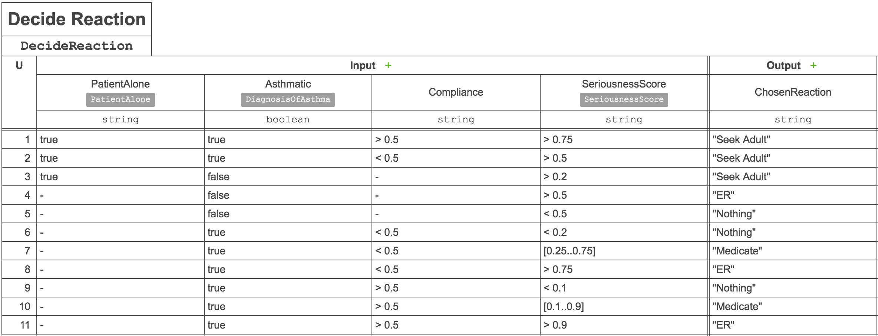

**Asthma Follow Up Pathway:**

**Asthma Diagnosis pathway:**

Whenever the patient has a health care encounter for any reason they will have a chance of being diagnosed with asthma, whether at the encounter is for symptoms or not and whether asthmatic or not.

A patient can only be diagnosed once, if they enter this pathway with a diagnosis they will be put onto the No Diagnosis node. Otherwise the practitioner will consider a diagnosis of asthma and a diagnosis could be made.

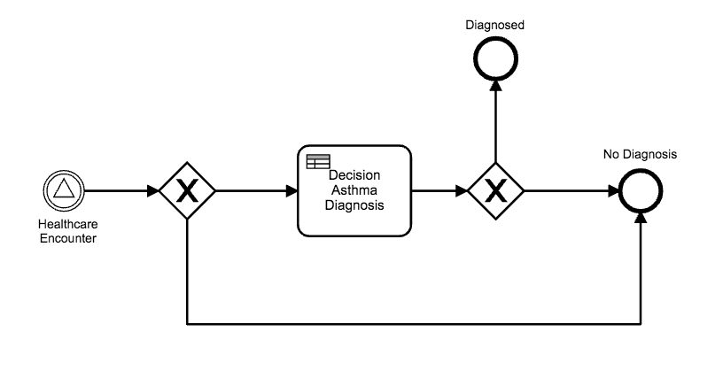

The asthma diagnosis is currently dictated by a chance of a correct or incorrect decision. This needs citation for percentages if available. Also this decision can be replaced with a series of tests or a decision based on already known information about the patient according to the practitioners policy.

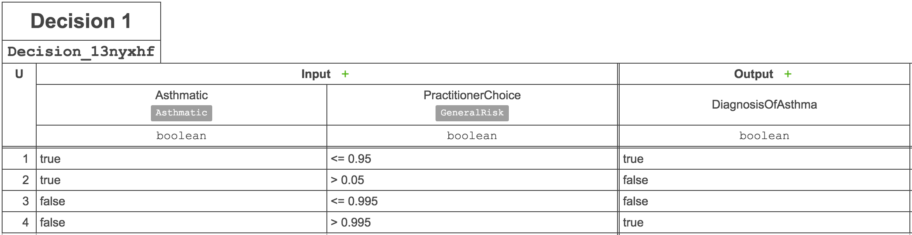

References:

[1] <https://www.asthma.org.uk/about/media/facts-and-statistics/>

[2] <https://www.asthma.org.uk/advice/severe-asthma/what-is-severe-asthma/>

[3] <https://asthma.net/basics/classifications/>